Accessing Parent/Student Information

- Navigate to Charms landing page at www.charmsoffice.com .

- Log on:

- Click the green “ENTER” button, and then click “Parents/Students/Members” from the drop down menu. The Charms Parents/Students/Member Area log in screen will display,
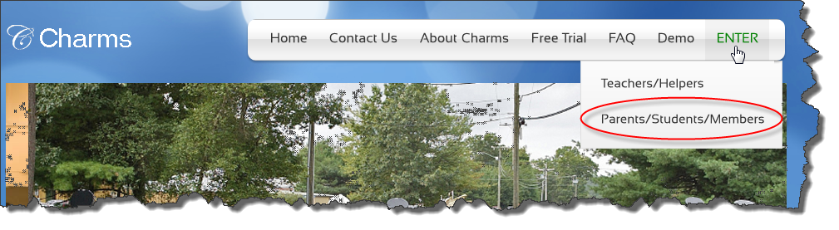

- Enter School Name in Your School Code field (not case sensitive)
- Click ‘Enter Charms’ button. The screen will display asking for Student Area Password
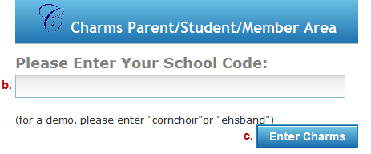

- Enter your Student’s FCPS ID Number. Click Enter. The Charms Home page will display.

Change Password
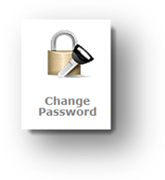
To change Password from Student ID (Acceptable to leave as student ID):

- From the Home page, click the Change Password icon – The Change Student Password screen will display
- Enter Student ID in the Old Password field
- Enter new password into the New Password field and Confirm New Password fields (must be at least 9 characters)
- Enter a hint that will be helpful in remembering the new password in the New Password Hint field.
- Click Change Password button- The Home page will display.
Note: For all future logins, the new password will be entered into the Student Area Password field. Also note, passwords are CASE-SENSATIVE, so if a password was created that has Upper Case then it must be entered exactly as it was created.

Update Information

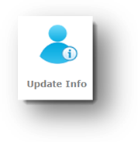Verify Student Information (Important for effective communication with teacher):

- From the Home page, click the Update Info icon – The Update Student Detail screen will display.
- Confirm student’s information
- Enter any changes and click the Update button - The screen will refresh displaying changes.
- Click the Home icon to return to Homepage

Handouts & Files

- To View or Print Handouts:

- From the Home page, click on Handouts & Files icon. The Files & Handout screen will display with the schools files tab active.
- 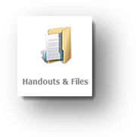Click appropriate folder to view/print related handout
- Click on the desired file to open
- Click Back to Folder List to select additional handouts or to upload a file.

- To Upload a Scanned/Saved File:

- From the Home page, click on Handouts & Files icon. The Files & Handouts screen will display with the School Files tab active.
- Click My Files tab. The file upload screen will display.
- Click Browse button. The Choose File to Upload box will appear.
- Locate the file and click file name to populate File Name field.
- Click Open. The Files & Handouts screen will display and file location/name will populate the Upload to Teacher field.
- Click Upload File button.
- The list of uploaded files will display below with links to the files for viewing.

Finances

To view Finances for Students:

- From the Home page, click the Finances icon. The Student Financial Statement screen will display.
- Total Balance due – is a total of all monies due. Balances from previous years are listed under Student Miscellaneous Ledger Detail – this includes money still owed from previous years.
- Positive Balances will be automatically applied towards student’s fee and trip balance
- Sample of a student financial record can be found on the last page of this handout.

Make a Payment through SchoolPay

- From the Home page, click the Finances icon – Student Financial Statement will display.
- To make a payment:

- Click on desired Payment button, a screen will display
- Click the Pay button – Charms will connect to SchoolPay
- Enter payment information/make payment
- Click Return to Charms to complete the process and display the updated Student’s record reflecting the payment.

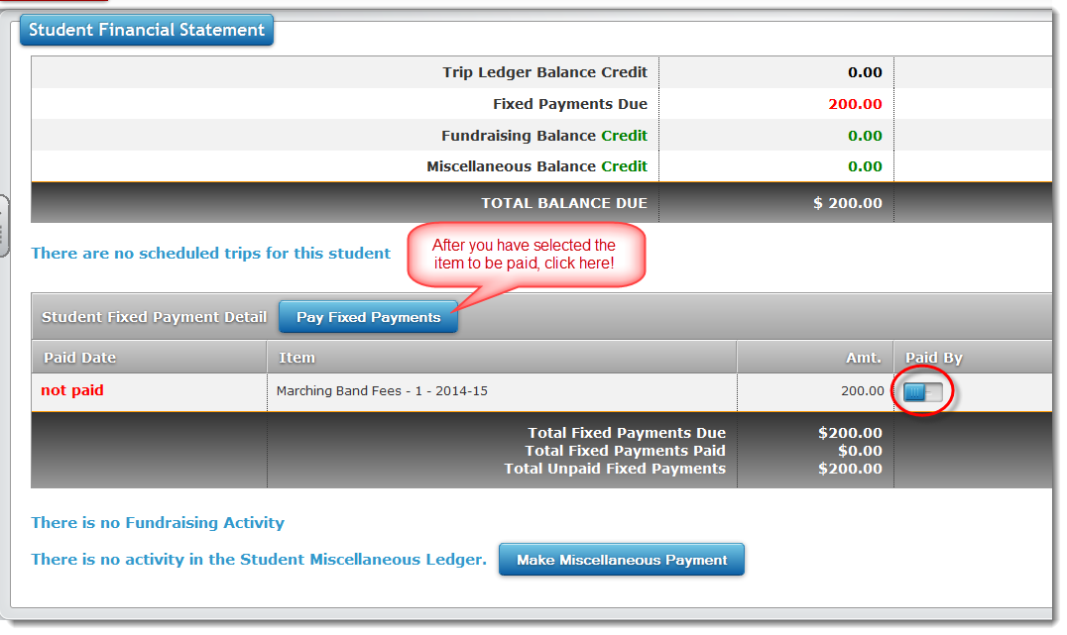

Calendar

- To access the calendar:

- From the Home page, click the Calendar icon
- 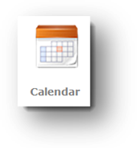Calendar will display – When selected, events will display in a popup window with detailed information about the event.

- To volunteer:

- From the Home page, click Calendar icon – Calendar will display
- Navigate to event using arrows next to month/year, Volunteers needed will be found in the detail with the raised hand that is a link to the volunteer screen.
- Click on the hand – The Volunteer Opportunities Screen will display for the event
- Volunteer activities will be listed below. Enter Name and E-mail address to sign up.
- Enter cell phone number and select cell phone carrier from drop down menu to receive a text reminder – If no text is desired, enter none in Cell Phone field.
- Once desired fields are completed click Sign-Up button. The screen will refresh with information saved.

Email Staff

To contact Band Director:

- From the Home page, click Email Staff icon – The Email Directors screen will display a list of available staff members
- Click envelope next to name of staff member to contact.

Logging Off

- When all desired actions are completed, exit Charms by clicking the red Exit Charms button.

Sample Student Finance Record:

